**Hotel-Side Hospital.**

* **Validate if Terraform is installed in the virtual machine.**

1. To check if terraform is installed, run the below command:

**terraform version**

1. Terraform is installed with version v1.8.3.

* **Install AWS CLI.**

1. To install AWS CI, run the below command:

**sudo apt update**

**sudo apt install awscli**

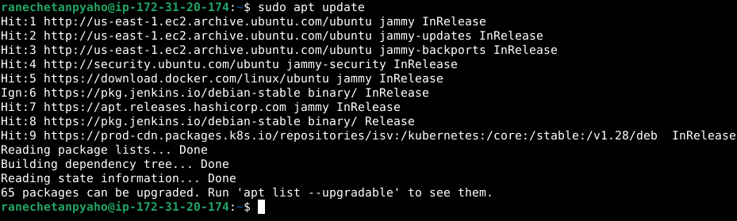

1. To Verify the installation, check the version:

**aws --version**

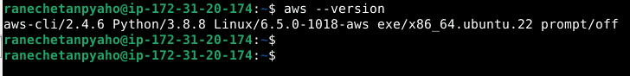

* **Configure AWS CLI connectivity with AWS Cloud.**

1. To configure AWS cli to connect with AWS cloud, run below command:

**aws configure**

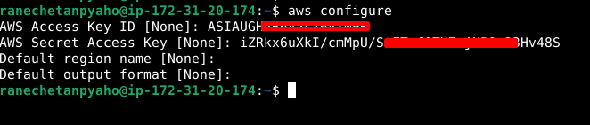

* **Create terraform scripts to create a new VM using autoscaling.**

1. Create all the terraform scripts including autoscaling.tf, VPC.tf, internetgateway.tf,

subnets.tf (public subnet), routetable.tf, route_table_association_with_public_subnets.tf and upload to below git hub repository .

**https://github.com/ranechetanp/ec2-autoscaling-using-tf.git**

1. Clone the Git repository by using below command:

**git clone** [**https://github.com/ranechetanp/ec2-autoscaling-using-tf.git**](https://github.com/ranechetanp/ec2-autoscaling-using-tf.git)

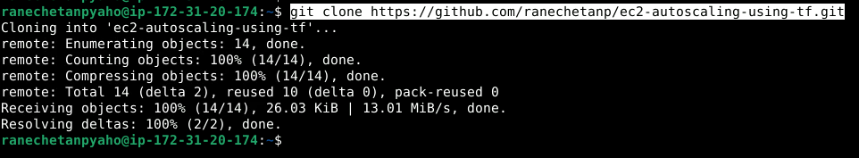

* **Execute terraform scripts.**

1. To run the terraform scripts go the repository directory , and run the below terraform commands:

**cd ec2-autoscaling-using-tf/**

**terraform init**

**terraform plan**

**terraform apply**

1. Check is instance has been created ,by navigating to ec2 console .

* **Connect to an instance and install the stress utility.**

1. Select the ec2 instance and click connect

1. To install stress utility , run the below commands:

**sudo apt update**

**sudo apt install stress**

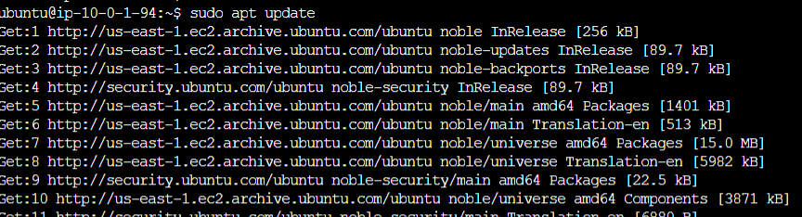

1. To check the stress version ,run the be low command:

**stress –version**

* **Validate if autoscaling is working by putting load.**

1. To increase the load on the existing ec2 instance, run the below command:

**sudo stress --cpu 4 -v --timeout 3000s**

1. As the CPU load increase , we see the second instance get created .

1. As the CPU load increase , we see the second instance gets deleted .

